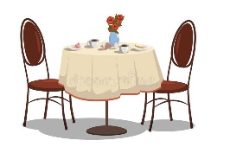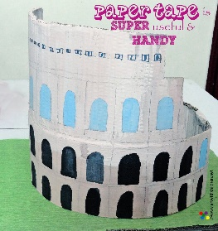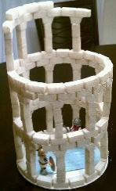

**Maths**

Carry out a survey asking people’s favourite pizza toppings. Create a bar chart to show the data collected.

**PSHE**

Think about some of the other people in the community who are struggling during this time. Create a lovely card or letter and send it to them.

You could always write to one of the residents at **Riverside Place Plaxton Way, Ware SG12 7FB.**

**Role Play/Imagination**

Could you try and create your own Italian menu and set up your own restaurant at home.

Don’t forget your best waiting skills and make sure to add the bill up correctly.

**Year 4**

**Activities to explore at home.**

**Cooking**

Either using your own recipe or the one attached, try to make an Italian dish. Don’t forget to weigh the ingredients carefully.

We would love to see a

picture of your food.

**D.T and Art**

Using any materials, you can find at home, can you make your own version of the Colosseum in Rome.

Here are some ideas below.

**Number facts**

Create your own maths board game, using an old piece of cardboard. This could be similar to snakes and ladders but each time you land on a square you answer a times table question. Your ideas are much better than ours!



**English**

* You have discovered a new unfound location. Create and write a post card to your family or friends to tell them about this new place.
* You have now been at this new location for five days and nights. Create a diary entry explaining the events each day.