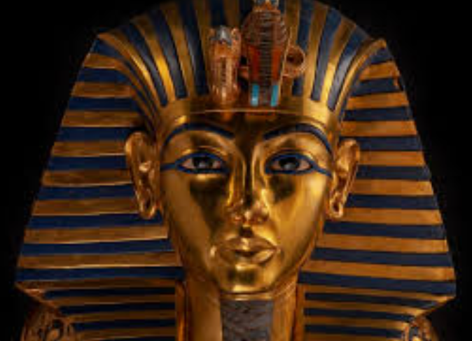
Year 3
Summer Newsletter 2025

Dear parents/carers,

Welcome back! We hope you had an enjoyable and restful Easter break. The children have made a great start to summer term impressing us with their enthusiasm and commitment to learning!

English: During our first few weeks of the term, the children will be looking at adventure stories, using the text ‘How to Live Forever’. They will be asking questions about the book and discussing the key features of an adventure story. Continuing with the How to Live Forever book, the children will create settings for their own adventure story and write an alternative ending to the book. We will then move on to our poetry unit where the children will be exploring different styles of poetry. They will start by learning what poetry is and techniques that are used to create feelings and pictures in the mind. Following this the children will be reading, performing and writing different styles of poetry.
After half term, we will be looking at the text: Azzi In Between and writing a recount, in diary form, for Azzi’s journey to England.

Maths: Throughout the first week of the term, we will be working on a division topic using our multiplication knowledge. By the end of the summer term 1, children will be able to write and calculate mathematical statements for division using the multiplication tables that they know, including for two-digit numbers times one-digit numbers, using mental, and progressing to, formal written methods. Before breaking up for the May half term, in year 3, we will be learning all about time. The children will have the opportunity to learn how to tell the time (both on a digital and analogue clock), calculate duration and work out various word problems involving: seconds, minutes, hours, days, weeks, months and years. In our final term of summer, the children will mostly recap all their previous learning including place value, the four operations (addition, subtraction, multiplication and division) and measuring using various units e.g. kilograms.

Topic (History and Geography): During the first half of the term, we will be finding out about The Ancient Egyptians. We will start off by understanding when Ancient Egyptians lived and where Egypt is. We will look at how long the period lasted for comparing it to when other periods of history occurred on a timeline. By looking at artefacts from this time we will understand how Ancient Egyptians lived their lives and what they were especially good at. Of course, we will look at mumification and afterlife, leading us to discover Tutankhamun’s tomb!
In the second half of the term, we will learn about modern Egypt: locating it geographically and understanding its climate, culture and touristic values.

Science: In the first half of the term, we will be studying all about ‘Animals Including Humans.’ Children will be able to identify the types of nutrients that humans need and understand that different nutrients are needed by different animals during our first few lessons. We will then move onto learning about the human skeleton and being able to explain how muscles allow movements. During the second half of the term, Year 3 will be starting their science topic all about Forces. Throughout the lessons, the children will have the opportunity to investigate how magnets work depending on the surfaces and continue to work on their working scientifically skills.

Art and DT: Children will be given many opportunities to unleash their creative flair throughout our topic, Ancient Egypt, for the term. Children will be designing and making a template for an Egyptian collar and applying individual design criteria and following their design criteria to create an Egyptian collar. We will start the second half of the term by learning some practical cooking skills on a Wednesday morning in DT.

Computing: In Summer 1, the children will learn about desktop publishing, this focuses on them learning skills such as changing fonts and inserting images. During this unit, learners will become familiar with the term’s ‘text’ and ‘images’ and understand that they can be used to communicate messages. Following on from this, the children will have the opportunity to use Scratch again and will learn how to programme effectively in the second half of the term. This unit explores the links between events and actions, whilst consolidating prior learning relating to sequencing.

Music: We will start the summer term with The Ancient Worlds topic, focusing on the structure of musical pieces and exploring tuned and untuned instruments to create repetitive music based on ostinato. The children will explore musical phrases, melodic imitation and rounds. Following on from this we will move onto The Human Body topic where the children will learn about call and response songs whilst learning a song to perform.

R.E and PSHE: Throughout the next two terms in R.E, we will continue to look at key aspects of both Christianity and Sikhism. In the first summer term, children will be learning all about relationships and their responsibilities as a global citizen. Following on from this topic, the Year 3 children will start a very important topic ‘Changing Me’. A letter with more information will be sent out before the May half term break.

P.E and Swimming: On Thursday afternoons, the children will have P.E with Mr Chivers. Please bring P.E kits in on a Monday as we may be practising for sports day throughout the week. We are pleased to inform you that during the second half of Summer Term, Year 3 children will be having their swimming lesson at Ware Priory Lido on Friday afternoons. The lessons will start on Friday 6th June and will continue until Friday 11th July 2025. The children should bring a swimming costume (not a two-piece) or trunks, a swimming hat and towel.

Things to remember/important information:

Uniform
Please be aware that children need to wear full uniform which in KS2 includes a tie (available from the school office). Long hair needs to be tied back with a hair tie/ small bow at all times and only a single pair of small ear studs are permitted. Make-up and nail varnish are not permitted.

Reading
At St Catherine’s, the children are expected to read at home daily, whether independently or with an adult. It is important that children have the opportunity to read regularly with an adult and to discuss the texts to secure their comprehension. Thank you for your support in noting in your child’s reading record that they have read, as well as ensuring both book and reading record come to school daily. Children unable to read at home a minimum of three times, will be invited to a reading club to support their progress.

Home learning:
To support curriculum expectations in lower key stage 2, the children will be set a grammar, spelling or a reading comprehension task and a maths task each week and in addition, will be expected to practise their times tables regularly.. Tasks will be set on a Friday to be completed by the following Thursday. If children are unsure of a task, it is their responsibility to seek support from their teacher before the homework is due in, giving them time to complete it.

Nut Allergies
A quick reminder that we do have children at our school with severe nut allergies, which can be life threatening. With this in mind, please can you ensure that packed lunches and snacks do not contain nuts of any kind. This does include sesame seeds, Nutella and some cereal bars. Please check wrappers carefully. Thank you for your co-operation with this matter.

We would like to take this opportunity to say how much we are looking forward to the remaining time of year 3. Please do feel free to contact us if you have any questions or concerns. If you feel that you have anything to contribute to our topic, whether it be skills, knowledge or resources, please let us know.

Thank you in advance for your help and support.

Mrs Clay and Mr Boye

Year 3 Teachers

For an overview of Topics and Curriculum areas taught this year, as well as more detailed information about each of these, please visit the school website:
https://www.stcatherines.herts.sch.uk/curriculum/

