**Tapestry website**: https://eylj.org/login

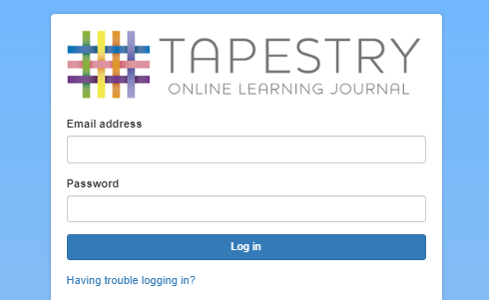

**Login Page –** enter your email address and password

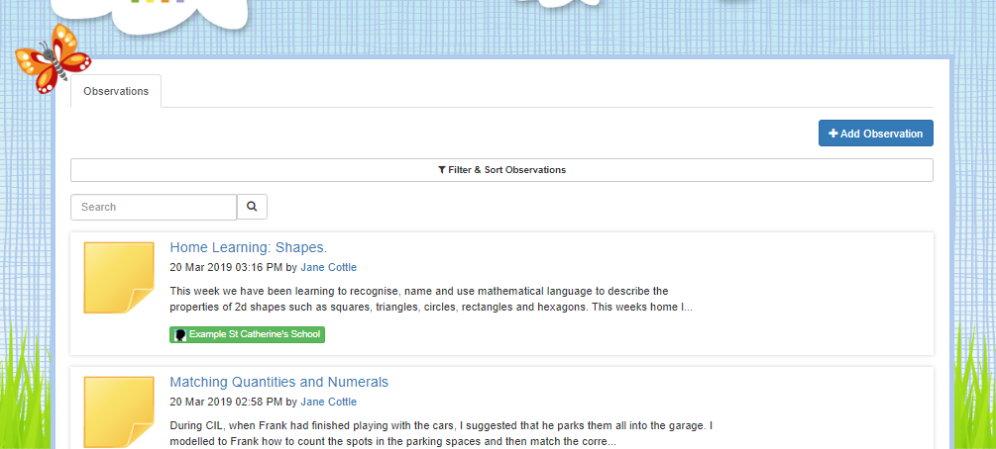

Observation by Early Years staff. **Click on the title of the observations to read them in more detail.**

**Add observation** button. Press here if you want to add an observation from home.

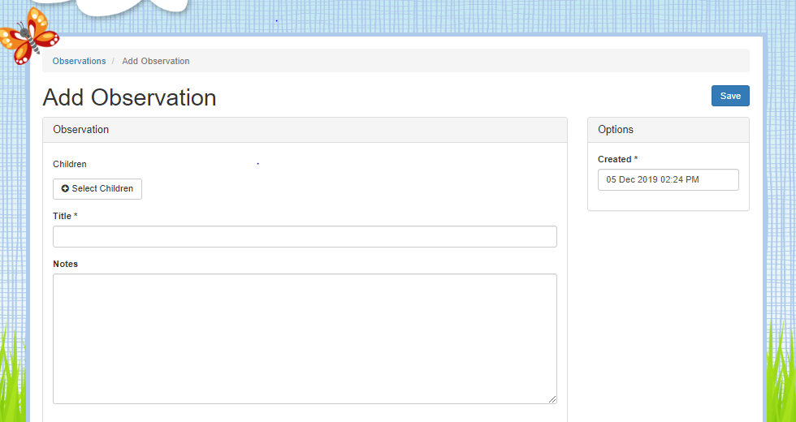

Once you have clicked **add observation** you will arrive at this page.

Select your child from the drop down menu.

Enter a title and observation notes for your observation

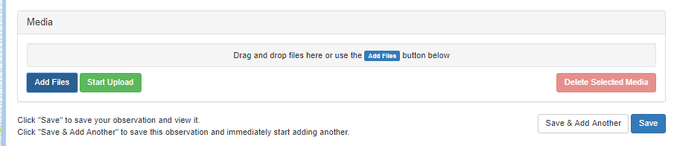

Finally, save your observation by clicking **save.**

Add photos or a video (maximum 1 min in length) using the **add files** button then click start **upload**.

**Ways you can use Tapestry to support your child’s learning:**

**You can support your child to achieve their next steps in learning, through activities that you may do at home. Let us know how they are getting on by adding a comment.**

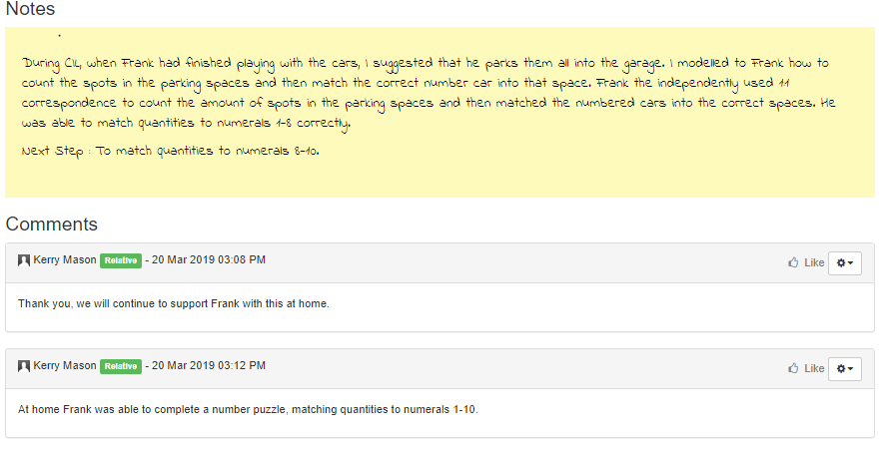

**You can add photos and comments about things your child has done outside of school. We can then talk about it in school and share their successes. You can use add your own observations using photos/ videos and comments to record your child’s learning and achievement when having a go at home learning tasks set from the Early Years team.**

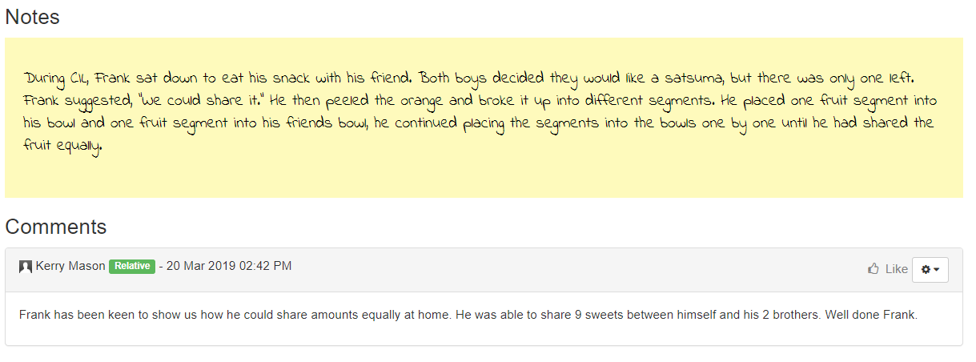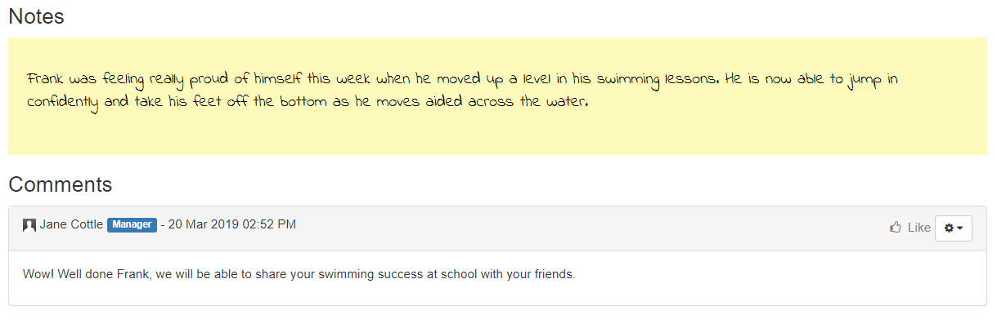

**You can tell us if your child has particularly enjoyed an activity and talks about it at home. Tell us if your child continues to extend their learning at home.**

**Please see a member of the Early Years team if you are experiencing any problems with Tapestry or need any further support with using Tapestry to support your child’s learning.**