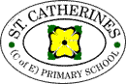
Year 3 Curriculum Rolling Programme 2024-2025

 | Autumn 1 |  | Autumn 2 |  | Spring 1 |  |  |  | Spring 2 |  |  | Summer 1 |  |  | Summer 2
 | The Local Area |  | Crime and Punishment |  | Riotous Royalty |  |  |  | The Paris Basin |  |  | Ancient Egyptians |  |  | Modern Egypt
Main Curriculum focus | Geography |  | History |  | History |  |  |  | Geography |  |  | History |  |  | Geography
Topic Enrichment  – Brilliant beginning?  - Exciting End? | Walk into Ware |  | Police/Magistrate visit |  | Royals themed day dress up |  |  |  | + |  |  | School trip?  Egyptian themed day dress up
Coverage:
English | Assessments SPaG (1 week)  Traditional Fables (3 weeks)  Writing and performing a Play- linked to Fables (2 weeks)  Recount- Newspaper report (2 weeks)  Crime/Mystery Stories- (3 weeks)- Cops and Robbers by Janet & Allan Ahlberg  Instructions (2 weeks)- linked to torture device art |  |  |  | Traditional Tales- Fairy Tales- alternative versions  Write a traditional tale from a key characters perspective  i.e. The Wolf’s story, what really happened to Little Red Riding Hood by Toby Forward/Honestly, Little Red Riding Hood was Rotten by Trisha Speed Shaskan/The True Story of the 3 Little Pigs (4 weeks)  Explanation- linked to Fairy Tales (2 weeks)  Poetry- - Structure → haiku, tanka and kennings (2 weeks)  Reports- Pirates (3 weeks) |  |  |  |  |  | Adventure Stories- focusing on plot (5 weeks)  Persuasion- persuasive letter writing (3 weeks)  Take One Book/Narrative (2 weeks)  Poetry
Maths | 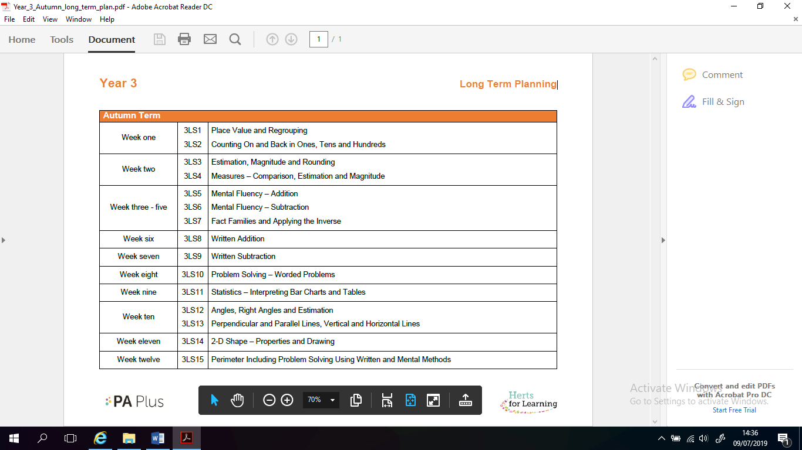 |  |  |  | 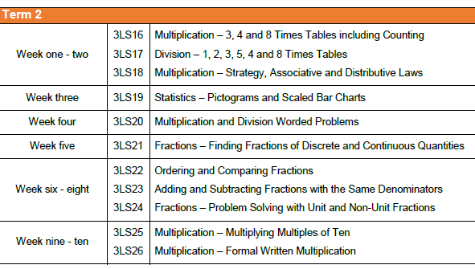 |  |  |  |  |  | 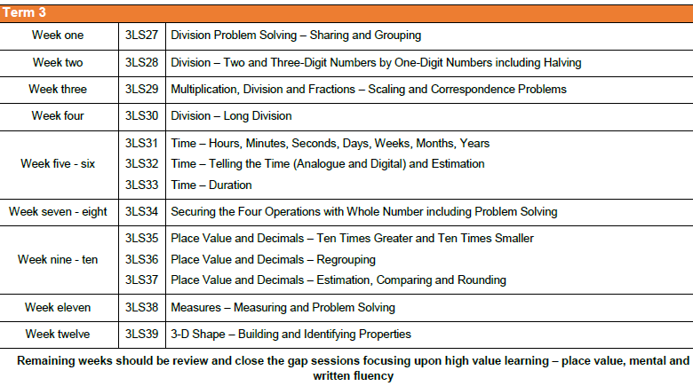
Science | Light  - Find patterns in the way that the size of a shadow changes  - Notice that light is reflected from surfaces  - Recognise that light from the sun can be dangerous and that there are ways to protect their eyes  - Recognise that shadows are formed when the light from a light source is blocked by a solid object  - Recognise that they need light in order to see things and that dark is the absence of light |  | Rocks  - Compare and group together different kinds of rocks on the basis of their appearance and simple physical properties  - Describe in simple terms how fossils are formed when things that have lived are trapped within a rock  - Recognise that soils are made from rock and organic matter |  | Plants  - Explore the part that flowers play in the life cycle of flowering plants, including pollination, seed formation and seed dispersal  - Explore the requirements of plants for life and growth (air, light, water, nutrients from soil and room to grow) and how they vary from plant to plant  - Identify and describe the functions of different parts of the flowering plants: roots, stem/trunk, leaves and flowers  - Investigate the way in which water is transported in plants |  |  |  |  |  | Animals Including Humans  - Identify that animals, including humans, need the right types and amount of nutrition, and that they cannot make their own food; they get nutrition from what they eat |  |  |  | Forces and Magnets  - Compare and group together a variety of everyday materials basis of whether they are attracted to a magnet, and identify some magnetic materials  - Compare how things move on different surfaces  - Describe a magnet as having two poles  - Notice that some forces need contact between objects, but a magnetic force can act at a distance  - Observe how magnets attract or repel each other and attract some materials and not others  - Predict whether two magnets will attract or repel each other, depending on which poles are facing
Geography | The Local Area  See MTP for objectives |  |  |  |  |  | Paris Basin  See MTP for objectives |  |  |  |  |  |  |  | Modern Egypt  See MTP for objectives
History |  |  | Crime and Punishment  See MTP for objectives |  | Riotous Royalty  See MTP for objectives |  |  |  |  |  | The Ancient Egyptians  See MTP for objectives
RE | Sources of Wisdom | Symbols and Actions |  | Beliefs and Practices | Identity and Belonging | Prayer, Worship and Reflection |  |  |  | Beliefs and Practices | Justice and Fairness |  | Human Responsibilities and Values |  |  | Ultimate Questions
Computing | Connecting Computers |  | Stop Frame Animation
DT & Art | Nutrition- Cooking |  |  |  | Potential projects:  Travel brochure/posters  Pointillism technique |  |  |  |  |  | Potential projects:  Death Masks  Canopic Jars  Hieroglyphics  Egyptian Gods
Music | See Music Express for objectives |  | See Music Express for objectives |  | See Music Express for objectives |  |  |  |  |  | See Music Express for objectives |  |  |  | See Music Express for objectives
MFL | Unit 1:  Bonjour |  | Unit 2:  En classe |  | Unit 3:  Mon corps |  |  |  | Unit 4:  Les animaux |  | Unit 5:  La famille |  |  |  | Unit 6:  Bon anniversaire
PE | Swimming |  | Swimming |  | Swimming |  |  |  | Swimming |  | Swimming |  |  |  | Swimming

